Technical analysis stock recommendation service and trading strategy

Our recommendations for the week beginning 23rd February 2015

Company Name | Date | Buy/Sell | Entry price (Sterling Pence) | Target  Price  (Sterling Pence) | Stop  Loss  (Sterling Pence) | Hedge  (Sterling Pence)
Home Retail Group PLC | 23.02.2015 | Buy | 204.0 | 227.5 | 193.7

Home Retail Group PLC

HOME.L

Sector | General Retailers
Last closing price (23/02/2015) (p) | 206.7
52week High/Low (p) | 225.2/156.33
Market Cap (£ bn) | 1.65
Average volume (mn) | 2.21
P/E ratio (TTM) | 32.57
Sector P/E ratio(TTM) | 18.46

Business background and investment rationale
Home Retail Group Plc is a United kingdom-based home and general merchandise retailer. The Company is organized into three business segments: Argos, Homebase and Financial Services together with Central Activities.
Increase in like-for-like sales at Argos and Homebase
In a trading statement announced in January, for the 18 weeks ending 3 January 2015, Argos traded well with 0.8% increase in sales to £1.82bn. This was driven by continued success in consumer electronics and electrical and supported by growing internet and mobile commerce sales. Argos’s total like-to-like sales increased by 0.1% and internet penetration accounted for 46% of total sales including mobile commerce which grew by 40% and accounted for 28% of total sales. Argos gross margin was up by 25 basis points driven by a reduced level of promotional activity reflecting the more cautious trading stance adopted, together with the anticipated impact of favourable currency and shipping costs, partially offset by an adverse sales mix impact from the growth in margin dilutive electrical products.
Total sales at Homebase declined by 2.7% to £451.0m due principally to a reduction in net space of 3.3%. There were 12 store closures in the period, resulting in a total of 19 closures till 3rd January 2015. The Homebase portfolio has therefore reduced to 304 stores and remains on track to close a total of around 25 stores in the current FY15 financial year. Like-for-like sales increased by 0.6% in the period. There was growth in sales of seasonal products, principally as a result of the warm weather during the period.
Transformation plan for Argos
In order to address the competitive challenges, exploit marketplace opportunities and restore sustainable growth, Argos has developed a five-year transformation plan. The company aims to reinvent itself as a digital retail leader with a total sales target of £4.5bn and a mid-single digit operating profit target by 2018. The plan is underpinned by an investment of £300m to be split equally over three years, during which Argos aims to transform itself from a catalogue-led business to one that is digitally-led.
Technical outlook
On the daily chart, Home Group is making lower highs above 186.0p indicating an uptrend in the stock. MACD (moving average convergence/divergence) is positive and in MACD 12 day EMA (exponential moving average) is above 26 day EMA, indicating a positive trend is forming in the stock.14 day RSI (relative strength index) is above 60 indicating strength in the positive trend. The stock is also trading above 20 and 50 day EMA, again indicating a positive trend. 14 day positive DMI (directional moving index) is above 14 day negative DMI while 14 day ADX (average directional index) is near 22 and rising pointing to a positive trend. The stock has support near 186.0p and resistance near 220.0p.
Trading strategy
The stock can be bought around 204.0p with a profit target 227.5p and stop loss of 193.7p.

TTM- Trailing Twelve Month

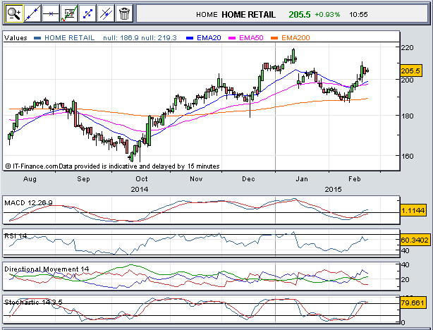
Daily chart (HOME.L)

Stock Updates
TalkTalk Telecom Group PLC
On the daily chart, TalkTalk positive trend strengthened after it rebounded higher from the low of 303.0p. MACD is positive and in MACD 12 day EMA is above 26 day EMA, further suggesting strength in the positive trend.14 day RSI is above 60 indicating strength in the positive trend. 14 day positive DMI is below 14 day negative DMI while 14 day ADX is near 14 and falling pointing to a consolidation in the stock. The stock has support near 296.0p and should be a hold with a profit target of 344.62p and a stop loss at 293.5p.
GKN PLC
On the daily chart, GKN is making higher lows above 284.0p indicating a positive trend in the stock. MACD is positive and in MACD 12 day EMA is below 26 day EMA, indicating a consolidation in the stock.14 day RSI is above 60 indicating strength in the positive trend. 14 day positive DMI is above 14 day negative DMI while 14 day ADX is near 22 indicating a positive trend in the stock. The stock has support near 381.0p and resistance at 400.0p. The stock should be a hold with the same profit target 403.8p and stop loss at 343.8p.
Just Eat PLC
On the daily chart, Just Eat hit the profit target of 378.1p indicating positive trend in the stock. MACD is positive and in MACD 12 day EMA is above 26 day EMA, suggesting a positive trend in the stock. 14 day RSI is above 60 indicating strength in the positive trend. The stock is also trading above 20 and 50 day EMA, again indicating a positive trend. 14 day positive DMI is above 14 day negative DMI while 14 day ADX is near 36 and rising pointing to a positive trend. All the positions should be closed for the stock.
Capita PLC
On the daily chart, Capita is making higher lows above 1000.0p, indicating a positive trend in the stock. MACD is positive and in MACD 12 day EMA is above 26 day EMA, indicating a positive trend in the stock.14 day RSI is above 60 indicating strength in the positive trend. 14 day positive DMI is above 14 day negative DMI while 14 day ADX is near 18 indicating a positive trend in the stock. The stock has support near 1000.0p and should be a hold with a profit target 1226.8p and stop loss at 1044.85p.
SSP Group PLC
On the daily chart, SSP group is making higher lows above 228.0p indicating a positive trend in the stock. MACD is positive and in MACD 12 day EMA is below 26 day EMA, suggesting consolidation in the stock.14 day RSI is above 50 indicating strength in the positive trend. The stock is also trading above 20 and 50 day EMA, again indicating a positive trend. 14 day positive DMI is above 14 day negative DMI while 14 day ADX is near 15 pointing to a consolidation in the stock. The stock has support near 250.0p and should be a hold with a profit target 304.5p and stop loss at 259.3p.
Aveva Group PLC
On the daily chart, Aveva has formed a bottom after it made higher lows above 1184.9p, indicating a positive trend in the stock. MACD is positive and in MACD 12 day EMA is above 26 day EMA, indicating a positive trend in the stock.14 day RSI is above 60 indicating strength in the positive trend. 14 day positive DMI is above 14 day negative DMI while 14 day ADX is near 39 indicating a positive trend in the stock. The stock has support near 1264.0p and should be a hold with a profit target 1650.6p and stop loss of 1405.8p.
Carillion PLC
On the daily chart, Carillion is making higher lows above 310.0p, indicating a positive trend in the stock. MACD is positive and in MACD 12 day EMA is above 26 day EMA, indicating a positive trend in the stock.14 day RSI is above 70 indicating strength in the positive trend. 14 day positive DMI is above 14 day negative DMI while 14 day ADX is near 29 indicating a positive trend in the stock. The stock has support near 343.0p. The stock should be a hold with a profit target 395.3p and stop loss of 337.2p.
Laird PLC
On the daily chart, Laird is making higher lows above 285.0p indicating a positive trend in the stock. MACD is positive and in MACD 12 day EMA is above 26 day EMA, further suggesting a positive trend in the stock.14 day RSI is above 70 indicating strength in the positive trend. The stock is also trading above 20 and 50 day EMA, again indicating a positive trend. 14 day positive DMI is above 14 day negative DMI while 14 day ADX is near 10 pointing to a consolidation in the stock. The stock has support near 302.0p. The stock should be a hold with the same profit target 368.1p and stop loss of 313.5p.

